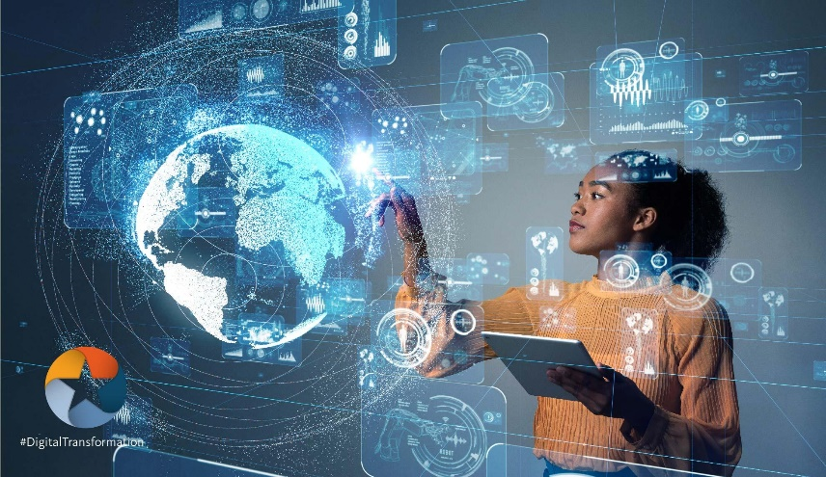AI

# What’s in the picture?

In the picture there is a women that work with an 3d image of earth with a lots of dates and informations in the space that we can read

# What do you think about it?

I think that that’s very nice and I’d to try this type of work with interactive 3d images.

I think that work in this type can be so easier to do.

# You have seen this in real life?

I’ve never saw this in real life but, I think that we aren’t very distant in technology for doing this.

# What do you think about AI?

I think that AI can be useful in future and can help us in work, medicine, rescue, critical emergency in our life, like robots drones, cam.